SYDNEY WESTERN CITY PLANNING PANEL

Panel Number: | PPSSWC-17
Application Number: | 2019/598/1
Local Government Area: | Camden.
Development: | Construction of two levels of basement parking, two x six storey residential flat buildings, containing 95 units upon proposed Lot 2 in approved subdivision of Lot 84 DP8979.
Capital Investment Value: | $33,823,195
Site Address(es): | 28 Ingleburn Road, Leppington
Applicant: | AE Design
Owner(s): | Balintore Ingleburn Rd Pty Ltd ATF Balintore Leppington Unit Trust
Date of Lodgement: | 31 July 2019
Number of Submissions: | Nil
Number of Unique Objections: | Nil
Classification: | Regionally significant development.
Recommendation: | Deferred commencement.
Regional Development Criteria (Schedule 7 of State Environmental Planning Policy (State and Regional Development) 2011): | General development capital investment value >$30 million.
List of All Relevant Section 4.15(1)(a) Matters: | - State Environmental Planning Policy (State and Regional Development) 2011.  - State Environmental Planning Policy (Sydney Region Growth Centres) 2006.  - State Environmental Planning Policy (Infrastructure) 2007.  - State Environmental Planning Policy No 55 - Remediation of Land.  - State Environmental Planning Policy No. 65 – Design Quality of Residential Apartment Development.  - State Environmental Planning Policy (Building Sustainability Index: BASIX) 2004.  - Sydney Regional Environmental Plan No 20 - Hawkesbury-Nepean River.  - Camden Development Control Plan 2011.  - Camden Growth Centre Precincts Development Control Plan.  - Apartment Design Guide.
List all Documents Submitted with this Report for the Panel’s Consideration: | - Assessment report.  - State Environmental Planning Policy (Sydney Region Growth Centres) 2006 assessment table.  - Apartment Design Guide assessment table.  - Camden Growth Centre Precincts Development Control Plan assessment table.  - Recommended conditions.  - Proposed plans.
Development Standard Contravention Request(s): | No development standard contravention proposed.
Summary of Key Submission Issues: | No submissions received.
Report Prepared By: | Adam Sampson, Executive Planner
Report Date: | November 2020.

Summary of Section 4.15 Matters

Yes
Have all recommendations in relation to relevant Section 4.15 matters been summarised in the Executive Summary of the assessment report?

Legislative Clauses Requiring Consent Authority Satisfaction

Yes
Have relevant clauses in all applicable environmental planning instruments where the consent authority must be satisfied about a particular matter been listed and relevant recommendations summarised in the Executive Summary of the assessment report?

Development Standard Contraventions

 | Yes | N/A
If a written request for a contravention to a development standard has been received, has it been attached to the assessment report?

Special Infrastructure Contributions

 | Yes | No
Does the application require Special Infrastructure Contributions?

Conditions

Yes
Have draft conditions been provided to the applicant for comment?

PURPOSE OF REPORT

The purpose of this report is to seek the Sydney Western City Planning Panel’s (the Panel’s) determination of a development application (DA) for construction of two levels of basement parking, two x six storey residential flat buildings, containing 95 units upon proposed Lot 2 in approved subdivision of Lot 84 DP8979 at 28 Ingleburn Road, Leppington.

The Panel is the consent authority for this DA as the capital investment value (CIV) of the development is $33.8 million. This exceeds the CIV threshold of $30 million for Council to determine the DA pursuant to Schedule 7 of State Environmental Planning Policy (State and Regional Development) 2011.
SUMMARY OF RECOMMENDATION

That the Panel determine DA/2019/598/1 for a residential flat building development pursuant to Section 4.16 of the Environmental Planning and Assessment Act, 1979 by granting deferred commencement consent subject to the terms and conditions attached to this report.

EXECUTIVE SUMMARY

Council is in receipt of a DA for a residential flat building development at 28 Ingleburn Road, Leppington.

The DA has been assessed against the Environmental Planning and Assessment Act 1979, the Environmental Planning and Assessment Regulation 2000, relevant environmental planning instruments, development control plans and policies.

A summary of the assessment of all relevant environmental planning instruments is provided below with a detailed assessment provided later in the report.

State Environmental Planning Policy (State and Regional Development) 2011. | The Panel is the consent authority for this DA as the development has a CIV of $33.8 million which exceeds the CIV threshold of $30 million for Council to determine the DA.
State Environmental Planning Policy (Sydney Region Growth Centres) 2006 (Growth SEPP). | The development is permitted with consent in the R3 Medium Density Residential zone and is consistent with the zones’ objectives and acceptable in terms of the Growth SEPP’s other matters for consideration.
State Environmental Planning Policy (Infrastructure) 2007 (ISEPP). | The DA was referred to Road and Maritime Services (RMS) for comment pursuant to the ISEPP and the comments received have been considered.
State Environmental Planning Policy No 55 - Remediation of Land. | Council staff have assessed a phase two detailed contamination assessment, which identified that the site had been used in the past for market gardening and agricultural purposes. A total of 36 shallow samples were taken across the site and were mixed to create composite samples. Test results of the samples collected revealed that heavy metals and pesticides were below the assessment criteria. Accordingly, the development does not require remediation and it is considered that the site is suitable for future residential use.
State Environmental Planning Policy No 65 – Design Quality of Residential Apartment Development | The development is largely consistent with the Design Quality Principles and the Apartment Design Guide.
State Environmental Planning Policy (Building Sustainability Index: BASIX) 2004 | The applicant has submitted a valid BASIX certificate in support of the DA that demonstrates that water, thermal comfort and energy requirements have been achieved.
Sydney Regional Environmental Plan No 20 - Hawkesbury-Nepean River (SREP 20). | The development is consistent with the aim of SREP 20 (to protect the environment of the Hawkesbury-Nepean River system) and all of its planning controls.

The DA was publicly exhibited for a period of 14 days in accordance with Camden Development Control Plan 2011. The exhibition period was from 27 August 2019 to 9 September 2019. No submissions were received.

The applicant proposes variations to the primary (4th level only) and secondary setbacks (corner lots) as contained in the development controls of Table 4-10 Clause 4.3.5(3) of Camden Growth Centre Precincts Development Control Plan. The variation to these setbacks assists in modulating and providing horizontal and vertical articulation to the facades, which would otherwise result in a uniform setback across multiple facades as per the development controls. The variation is assessed in further detail in this report and is supported by Council staff.

Based on the assessment, it is recommended that the DA be granted deferred commencement consent subject to the terms and conditions attached to this report.

KEY PLANNING CONTROL VARIATIONS

Control | Proposed | Variation
Front Setback – 6m. Balconies and other articulation may encroach into the setback to a maximum of 4.5m from the boundary for the first 3 storeys and for a maximum of 50% of the façade length. | Road No. 2 – Level 4 – 4.5m  Road No. 3 – Level 4 – 4.5m | 1.5m
Secondary setback – 6m | Road No. 1 – Ground to Level 6 – 4.5m (winter gardens on lower levels and a lift shaft on levels 5 and 6) | 1.5m

AERIAL PHOTO

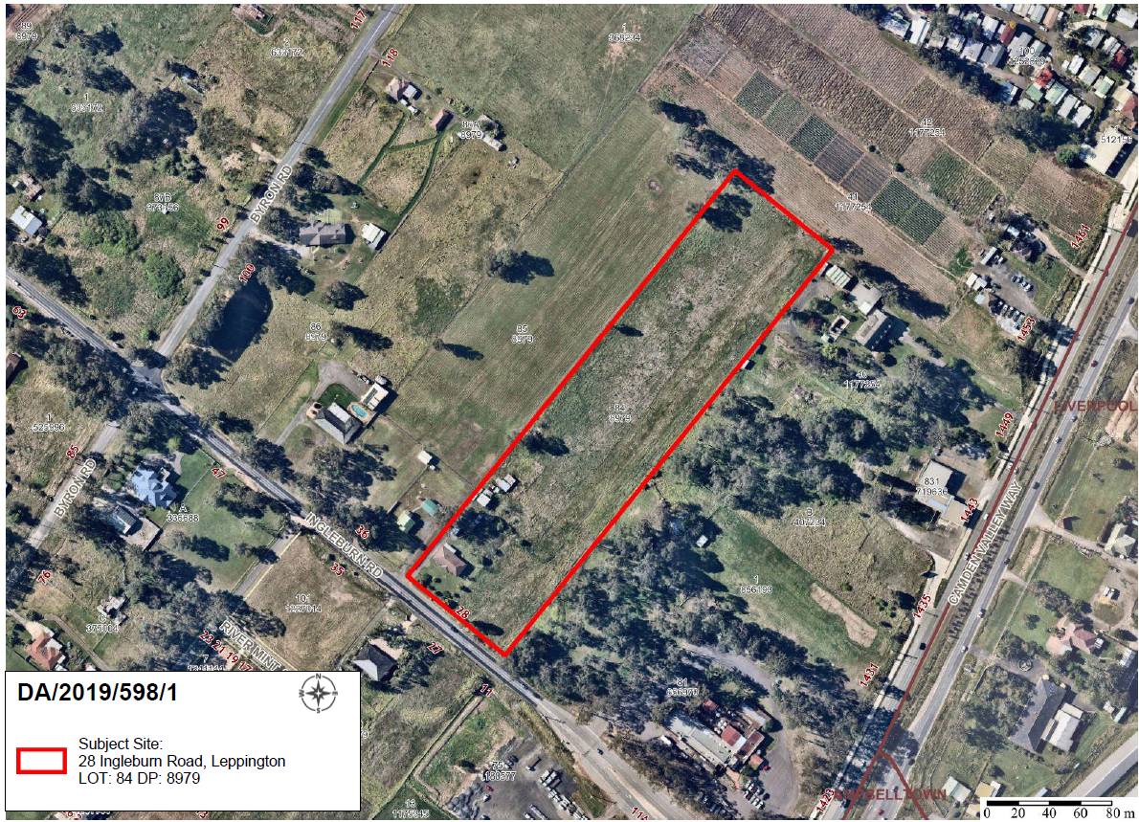

THE SITE

The site is commonly known as 28 Ingleburn Road, Leppington and is legally described as Lot 84 DP 8979 and has an overall area of 2.683 hectares. The site is rectangular in shape and is located on the northern side of Ingleburn Road. The site has a frontage of 80.47 metres to Ingleburn Road and has a depth of 333.45 metres. The land has a cross fall at the south east corner of Ingleburn Road towards the middle of the site and a cross fall from the north east property boundary towards the south west property boundary.

The site currently contains a single storey brick dwelling house and two detached outbuildings. The site is predominately clear of vegetation with clusters of vegetation adjoining the site at the north east, south east and south west corners of the site. The site is subject to biodiversity certification and is located within the Austral and Leppington North Precinct and the Leppington Major Centre of the South West Growth Centre. Ingleburn Road is currently a rural road, however it will ultimately be upgraded to be a two lane sub-arterial road.

The surrounding area is characterised by undulating topography, scattered vegetation, dams, market gardens and poultry farms and a range of rural and rural residential land uses. Camden Valley Way and Lockies Hotel lie to the east. To the north, south and west lay existing rural and rural residential properties that have been rezoned for residential development as part of the Leppington Major Centres, Austral and Leppington North Precincts and the Leppington Priority Precinct.

Leppington railway station is located approximately 1.5km to the north of the site. The site sits on the southern boundary of the Leppington Major Centre. The Leppington Precincts northern boundary is at the opposite side of Ingleburn Road.

ZONING PLAN

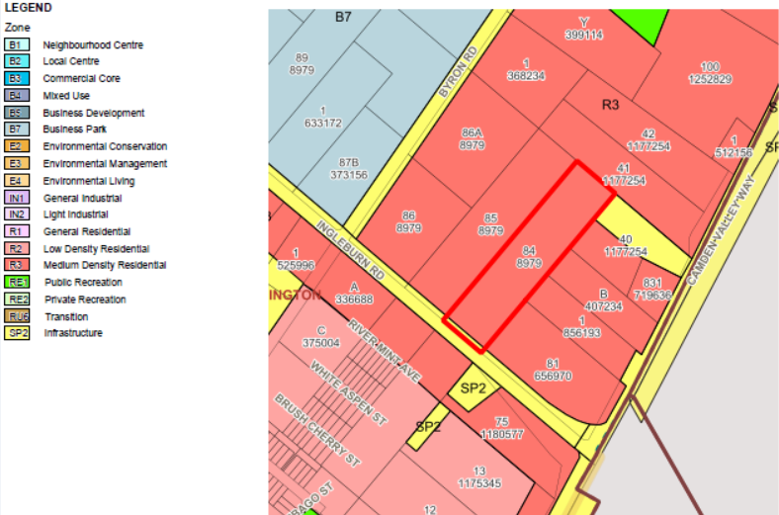

Indicative Layout Plan (Schedule 2 – Leppington Major Centre)

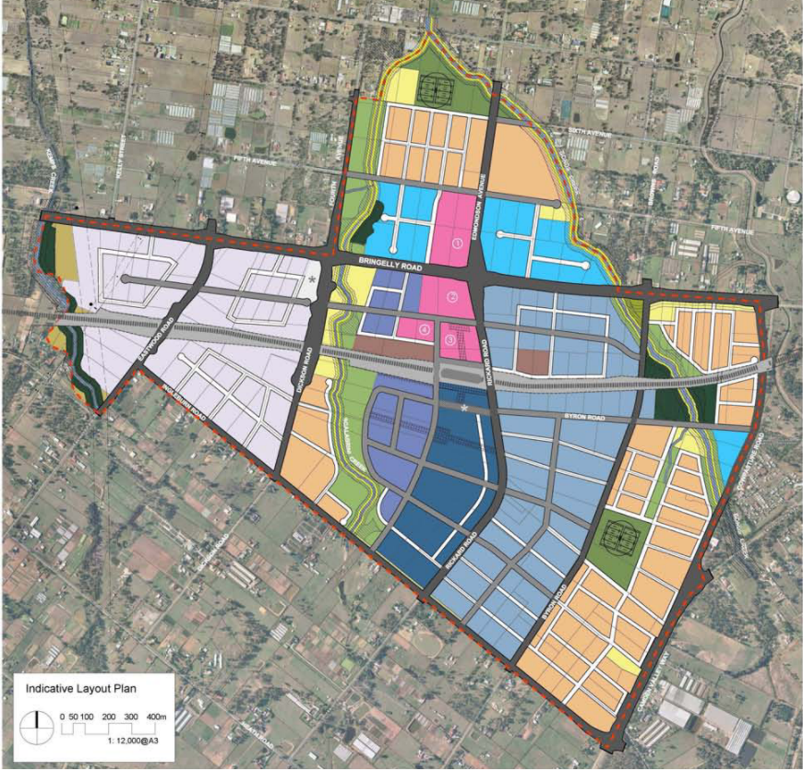
Site
HISTORY

The relevant development history of the site is summarised in the following table:

Date | Development
19th February 2018 | Refusal of DA/2016/1471/1 for construction of two x seven storey residential flat buildings containing 156 residential units and two basement levels containing 191 carparking spaces, landscaping and associated works on proposed Lot 2 in a resubdivision of 28 Ingleburn Road.
30th October 2018 | NSW Land and Environment Court Class 1 Appeal against DA/2016/1471/1 notice of discontinuance filed with the NSW Land & Environment Court.
12th December 2018 | Notice of orders made against DA/2018/1468/1 approving development (subdivision of one allotment into three (3) Torrens title lots and construction of roads) subject to a deferred commencement consent.

THE PROPOSAL

DA/2019/598/1 seeks approval for the construction of two levels of basement parking, two x six storey residential flat buildings containing 95 units upon proposed Lot 2 in approved subdivision of Lot 84 DP8979.

The DA is dependent upon a separate approval, granted by the NSW Land and Environment Court on the 12th December 2018, for the demolition of existing structures, tree removal, subdivision of the land into three (3) Torrens title lots and construction of roads, internal landscaping and street tree planting (DA/1468/2016). This DA establishes the site levels, and constructs Lot 3 and the associated roads for which this development relies upon for vehicular access and disposal of stormwater into the drainage system.

The development of Lot 1 and Lot 3 for the construction of residential flat buildings is also proposed under separate applications subject to DA/2019/596/1 and DA/2019/597/1, which are reported to the Panel separately for determination.

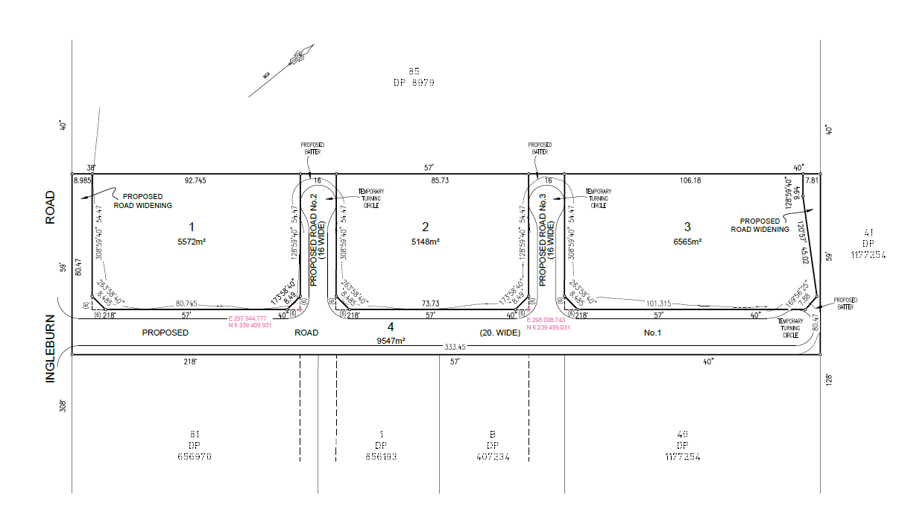
Image 1 – Plan of subdivision subject to DA/2016/1468/1

The applicant has modified a drainage swale proposed under the parent subdivision application provided along the full length of the north western property boundary to capture and convey external upstream catchment flows. A 3.2m drainage swale was approved along this boundary, however the proposed development seeks to narrow the swale to 1m (1.4m full width inclusive of retaining walls).

The applicant has been unable to demonstrate to Council’s satisfaction that the narrower swale will be able to accommodate the external upstream catchment area in its pre-development conditions for all storm events up to the 100-year ARI flowing towards Lot 2. The proposed narrower drainage swale also has resultant impacts upon the parent subdivision approval subject to DA/2016/1468/1 in respect to adjoining pit levels and pit capacities. As such, it is recommended that the application is issued with a deferred commencement consent until this issue is resolved to Council’s satisfaction.

Specifically, the development involves:

- Construction of two x six storey buildings containing 95 residential units, consisting of 10 x 1 bedroom units, 68 x 2 bedroom units, 17 x 3 bedroom units, including eleven adaptable units:

The building will be constructed of masonry and glazing. Wall finishes will consist of brickwork (two colours), render and painted finishes (two colours), hardiplank weatherboard and composite timber cladding.

- Construction of two levels of basement parking providing 127 parking spaces.

- Associated site works, including earthworks, drainage and landscaping.

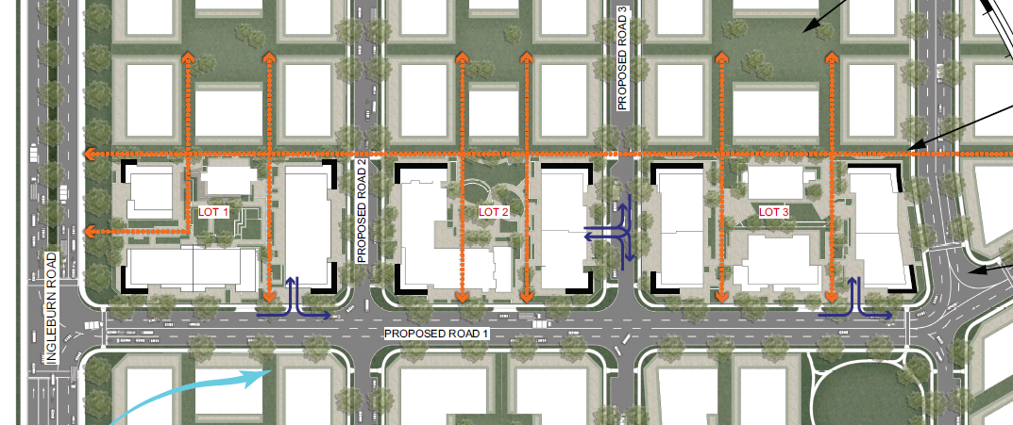
Image 2 – Site plan, with proposed adjoining development for context

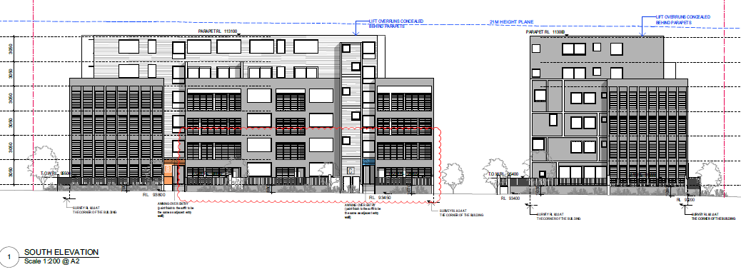
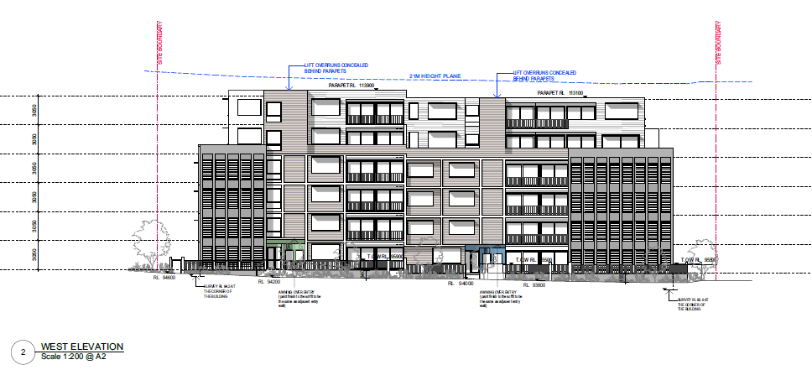
Image 3 – Southern (Road No. 1) and western (Road No. 2) elevations

PANEL BRIEFING

Council staff briefed the Panel on the DA on 30 September 2019. The following discussion provides an assessment of how the issues raised by the Panel at the briefing have been addressed:

- The Panel would generally expect to see a greenfield site such as this complying with applicable development standards and the relevant ADG controls.

The applicant has amended the development plans and no breach to the maximum height of buildings development standard is proposed. In respect to satisfying the Apartment Design Guide (ADG), the development satisfies all criteria and objectives, with the exception to three cross through apartments, which fail to achieve a width of 4m (Units A5.8 & A6.3 3.6m wide)(D1.1 -3.6m at one end, opposing end 4m in width).

- The Panel would prefer to see compliance with the building separation and privacy standards rather than introducing high sill levels and privacy screens (which reduce internal amenity) to address avoidable non-compliances.

The proposed development on Lot 2 satisfies the visual privacy / building separation design criteria of the ADG.

- The Panel would need to be satisfied that solar access and deep soil requirements have been adequately addressed.
The development satisfies both of these ADG requirements.

- The layout design seems unimaginative. Architectural treatments and adaptions to the design would likely assist in creating a local environment for future occupants and the area. Attention to the way in which the three developments integrate should offer opportunities for improved design.

The architectural design of the development has evolved significantly from that originally presented at the briefing session held in September 2019. The development now provides modulation and articulation to create breaks in the facades and visual interest through:

- Emphasising the corners by pushing out to the 4.5m setback provision for the first four levels, providing strong street corners as urban markers and clear definition of the building from base to top. The urban markers are shared across the three lots to provide some continuity and integration of design.

- Modulating setbacks from 4.5m to 6m for the first four levels, which differ on each façade to avoid repetition of built form and creates visual interest.

- Use of varied materials that assist to visually break up the buildings into smaller, modulated blocks.

- Reducing the street wall height to four storeys with upper level setbacks on levels 5 and 6 to provide a human scale to the proposed development when viewed from the public domain.

The evolution of design is highlighted with a comparison of the façade and built form of the currently proposed development (as indicated in Image 3 above) against the originally proposed development (as indicated in Image 4 below).

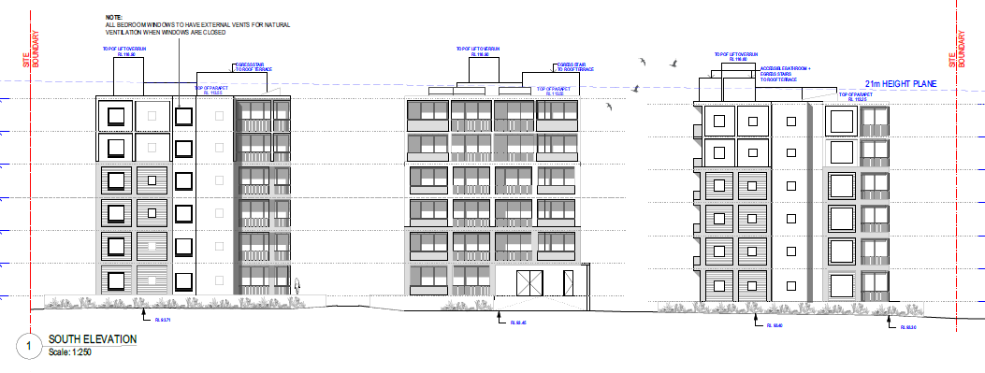
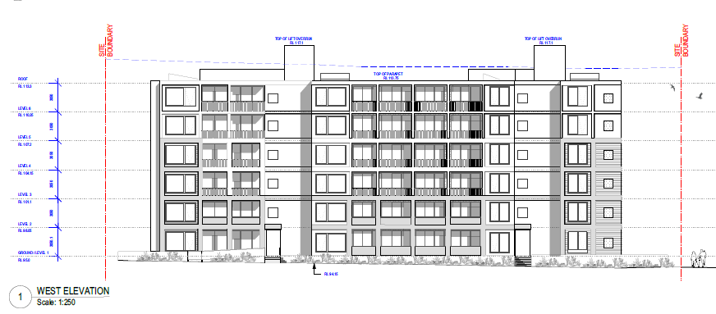
Image 4 – Southern (Road No. 1) and western (Road No. 3) elevations (originally submitted proposal)

- Increased density which results in several areas of non-compliance without improving the development in terms of internal amenity, and which compromises usability of the external landscaped areas and presentation of the building, may be an indication that some reduction in yield will be necessary.

Following revisions to the plans, the development yield of the proposal on Lot 2 has been reduced from 105 to 95 units, which equates to a reduction in density from 147.1 to 133.1 dwellings per hectare. As demonstrated within this assessment report and accompanying assessment tables, the development is now compliant with the maximum height of buildings development standard and generally complies with the objectives and controls contained in the DCP and ADG.

- The Panel notes the residential density and character for an area within the walking catchment of the DCP described in Table 3-1 “Typical Characteristics of Residential Net Densities” in the Camden City Council Growth Centre Precincts DCP. That character is relevant to assessing the compatibility of the development within its context.

Subject to Clause 1.3.2 and Table 1 – 2 of the Camden Growth Centre Precincts Development Control Plan, which summarises the controls that are applicable to the main types of development that are permissible in this DCP, Part 3 which contains Table 3-1 ‘Typical Characteristics of Residential Net Densities’ does not apply to residential flat building development.

The proposed development has been assessed against the nine (9) design quality principles of SEPP No. 65 – Design Quality of Residential Apartment Development and the requirements of the ADG and is considered to be an acceptable built form for the future urban character of the area and will make a positive contribution to that future context.

- The proposal breaches of the height limit will need to be justified.

The development plans have been amended and reduce the building height to 21m, which no longer breaches the SEPP’s maximum building height development standard.

ASSESSMENT

Environmental Planning and Assessment Act 1979 - Section 4.15(1)

In determining a DA, the consent authority is to take into consideration such of the following matters as are of relevance to the development the subject of the DA:

(a)(i) the provisions of any environmental planning instrument

The environmental planning instruments that apply to the development are:

- State Environmental Planning Policy (State and Regional Development) 2011.
- State Environmental Planning Policy (Sydney Region Growth Centres) 2006.
- State Environmental Planning Policy (Infrastructure) 2007.
- State Environmental Planning Policy No 55 - Remediation of Land.
- State Environmental Planning Policy No 65 - Design Quality of Residential Apartment Development.
- State Environmental Planning Policy (Building Sustainability Index: BASIX) 2004.
- Sydney Regional Environmental Plan No 20 - Hawkesbury-Nepean River.

State Environmental Planning Policy (State and Regional Development) 2011 (SRD SEPP)

The SRD SEPP identifies development that is State significant or regionally significant development.

The Panel is the consent authority for this DA as the CIV of the development is $33.8 million. This exceeds the CIV threshold of $30 million for Council to determine the DA pursuant to Schedule 7 of the SRD SEPP.

State Environmental Planning Policy (Sydney Region Growth Centres) 2006 (Growth SEPP)

The Growth SEPP aims to co-ordinate the release of land for residential, employment and other urban development in the North West Growth Centre, the South West Growth Centre and the Wilton Growth Area.

Site Zoning

A portion of the site is zoned SP2 Infrastructure (Classified Road) along the site’s entire western boundary parallel with Ingleburn Road for future road widening works to convert Ingleburn Road into a two lane sub-arterial road. This area is 80.47m wide and 8.985m deep and is identified for acquisition by Council.

The remainder of the site and majority of the site is zoned R3 Medium Density Residential.

Land Use Definitions

The development is defined as a ‘residential flat building’ as per the SEPP.

Permissibility

No works are proposed within the SP2 Infrastructure zone.
The proposed buildings will be restricted to the part of the site zoned R3 Medium Density Residential. The part of the site zoned SP2 Infrastructure (Classified Road) will be contained in a residue lot which will be used to upgrade Ingleburn Road into its ultimate configuration (as approved under DA/2016/1468/1 for the subdivision of the land into three (3) Torrens title lots and construction of roads).

Planning Controls

An assessment table in which the development is considered against the Growth SEPP’s planning controls is provided as an attachment to this report.

State Environmental Planning Policy (Infrastructure) 2007 (ISEPP)

The ISEPP aims to facilitate the effective delivery of infrastructure across the State.

Roads and Maritime Services (RMS)

Clause 100 – Development on proposed classified road

The DA was referred to RMS seeking concurrence pursuant to Clause 100 of the ISEPP. However, as no works are proposed upon the land adjacent to Ingleburn Road (which is proposed to be acquired for the upgrade Ingleburn Road) concurrence was not required to be obtained. In lieu, the RMS provided traffic related comments for Council’s consideration in the determination of the application.

State Environmental Planning Policy No 55 - Remediation of Land (SEPP 55)

The SEPP requires the consent authority to be satisfied that the site is suitable for its intended use (in terms of contamination) prior to granting consent.

The applicant has submitted a phase two detailed contamination assessment, which identified that the site had been used in the past for market gardening and agricultural purposes. A total of 36 shallow samples were taken across the site and were mixed to create composite samples. Test results of the samples collected revealed that heavy metals and pesticides were below the assessment criteria. Accordingly, the development does not require remediation and it is considered that the site is suitable for future residential use.

State Environmental Planning Policy No 65 - Quality Design of Residential Apartment Development (SEPP 65)

SEPP 65 aims to improve the design quality of residential apartment development and provides an assessment framework, the Apartment Design Guide (ADG) for assessing ‘good design’. The SEPP requires consideration of any development application for residential accommodation meeting the application criteria of the SEPP against the nine (9) design quality principles and the ADG. A copy of the assessment of the proposed development against the design criteria and objectives of the ADG is provided as an attachment to this report, with assessment of the application revealing that the development is largely consistent with the ADG and the design quality principles.

The proposed development has been assessed against the SEPP’s design quality principles:

Principle 1: Context and Neighbourhood Character

The entire area is undergoing a significant transition from rural/rural residential to an urban character, with substantial increases in height from single and two storey development to six storeys and greater. The development is located immediately adjacent to the Lockies Hotel to the south and is surrounded by former rural lots containing detached housing, which have been rezoned to R2 – Low Density Residential and R3 – Medium Density Residential to the west on the opposing side of Ingleburn Road and R3 – Medium Density Residential to the north, south and east.

While residential flat building development will be new to the area, the development has a distinct four storey street wall which will provide a human scale to the proposed development when viewed from the public domain.

The proposed development provides an acceptable built form for the future urban character of the area and will make a positive contribution to that future context. This has been done by achieving general compliance with the relevant planning controls that will also guide the development of that future character and context.

Principle 2: Built Form and Scale

The roof design is integrated into the overall built form and massing of the proposal by stepping the roof form to reflect the topography of the site. In addition, the development provides a range of building heights, upper floor setbacks, varying façade design, colours and materials and horizontal and vertical architectural elements projecting from the main façade to provide articulation and visual interest. The development also accentuates the corners of each building, and at the south east and south west along the future collector road (Road No.1), creating urban markers at the corners. Accordingly, the design is considered to be of a high standard and of architectural merit and desirable in establishing the Leppington Town Centre.

Principle 3: Density

The proposed development will achieve a density of 133.1 dwellings per hectare, which consists of 1, 2 and 3 bedroom apartments. The proposed density does not result in adverse impacts in respect to overshadowing or loss of visual privacy upon adjoining properties, nor is the development considered to be an unacceptable built form. Higher densities are considered appropriate in this location given its location in the Town Centre with good access to an emerging commercial centre, employment lands and public transport.

Principle 4: Sustainability

The proposed development will incorporate a number of sustainability features including solar access and natural ventilation consistent with the ADG objectives, attractive landscaped and usable communal open spaces, and compliance with BASIX requirements.

Bicycle storage exists within the development to promote alternative and sustainable transport options to and from the site.

Principle 5: Landscape

The proposed landscaping will achieve deep soil zones consistent with the ADG and co-located over the central communal open space area. Planter beds are also used to line and soften edges of hardstand areas, creating shading opportunities. The communal open space area includes tiered seating, and a combination of soft and paved surfaces, providing recreation and social interaction opportunities whilst being overlooked by the proposed apartments for safety and security. In addition, a children’s playground is located centrally within the communal open space area. The design of the communal open space area is considered to be inviting and will allow for a range of activities to be pursued.

Principle 6: Amenity

The proposed apartment layouts and designs are generally compliant with the ADG design criteria and will provide reasonable amenity for future residents. Due to the site’s proximity to Camden Valley Way and Ingleburn Road, winter gardens are proposed to enclose balcony open space areas for the first four levels of the development, predominately along the southern façade and at the eastern and western corners of buildings B and D. The winter gardens are provided with glazed openable louvres to allow sunlight to penetrate these areas and allow residents fresh air when desired and peace and quiet when closed, without limiting outlook to the public domain.

A choice of open space opportunities has been provided in the form of turfed areas, landscaped gardens and semi-covered terraces with seating.

Principle 7: Safety

The proposed apartment private open space areas and communal open space areas are well defined and legible, defining which areas are private and for communal use. The proposed buildings provide active frontages to all public roads, maximising passive surveillance opportunities. Controlled access will be provided to the proposed buildings via intercoms and key card access. Secure resident parking areas is provided in the basement.

Principle 8: Housing Diversity and Social Interaction

The proposed development provides a variety of apartment types and sizes, including eleven adaptable units. The development provides for ground floor communal open space areas to allow for a variety of active and passive recreational uses to be enjoyed by the residents of the development.

Principle 9: Aesthetics

The development has an interesting and balanced built form, which has been established through upper floor setbacks, varying façade design and horizontal and vertical architectural elements projecting from the main façade to provide articulation and visual interest. The development also accentuates the corners of the building creating urban markers along the future collector road (Road No. 1). A variety of durable, high quality materials are proposed, including large areas of brickwork and glazing, render and painted finishes (two colours), hardiplank weatherboard and composite timber cladding.

State Environmental Planning Policy (Building Sustainability Index: BASIX) 2004

The applicant has submitted a valid BASIX certificate in support of the DA that demonstrates that water, thermal comfort and energy requirements have been achieved.

Sydney Regional Environmental Plan No 20 - Hawkesbury-Nepean River (SREP 20)

SREP 20 aims to protect the environment of the Hawkesbury-Nepean River system by ensuring that the impacts of future land uses are considered in a regional context.

The development is consistent with the aim of SREP 20 and all of its planning controls. There will be no detrimental impacts upon the Hawkesbury-Nepean River system as a result of the development. Appropriate erosion, sediment and water pollution control measures have been proposed as part of the development.

(a)(ii) the provisions of any proposed instrument that is or has been the subject of public consultation under this Act and that has been notified to the consent authority (unless the Secretary has notified the consent authority that the making of the proposed instrument has been deferred indefinitely or has not been approved)

Draft Environment State Environmental Planning Policy (Draft Environment SEPP)

The development is consistent with the Draft Environment SEPP in that there will be no detrimental impacts upon the Hawkesbury-Nepean River system as a result of it.

(a)(iii) the provisions of any development control plan

The development control plans that apply to the development are:

- Camden Development Control Plan 2011 (requirements for notification); and
- Camden Growth Centre Precincts Development Control Plan.

Camden Growth Centre Precincts Development Control Plan

Planning Controls

An assessment table in which the development is considered against Camden Growth Centre Precincts Development Control Plan is provided as an attachment to this report.

Proposed Variation

The applicant proposes variations to the primary and secondary setbacks (corner lots) contrary to the development controls of Table 4-10 Clause 4.3.5(3) of Camden Growth Centre Precincts Development Control Plan.

The development controls specify that:

- Front setback of at least 6m with 1.5m balcony articulation encroachments permitted for the first three storeys for 50% of the façade length; and
- Corner lots require a secondary street setback of at least 6m.

The application proposes variations to balcony / winter gardens encroachments on Road No. 2 and Road No. 3 (front setback) to continue on the 4th level of the development at 4.5m and for balcony / winter gardens encroachments to exist on the secondary setback to Building B and D along the adjoining southern road (Road No. 2) at 4.5m from ground level to level 4.

The applicant has provided the following reasons in support of the proposed variations:

- Varied setbacks are provided between 4.5m to 6m to provide modulation, articulation, visual interest, reduction in perceived building bulk and provide clear hierarchical definition from base to top. Modulated articulation on the corners of the main streets creates urban markers.

This does not strictly comply with the numerical setback controls in the CGCDCP that only for articulation on Levels 1-3. However, the minor breaches to allow articulation on one additional level presents a better outcome to a compliant scheme as it contributes to the formation of strong urban markers, which are used across the three lots for continuity.

The proposed variations to both the front setback and secondary setback are considered reasonable and desirable to achieve and set the character for acceptable built form in the Leppington Town Centre. Variation to these setbacks assists in modulating and providing horizontal and vertical articulation to the facades, which in absence, would otherwise result in a uniform setback across multiple facades and excessive street wall height, with no human scale as per the development controls. The development also accentuates the corners of each building, creating urban markers at the corners. Accordingly, the proposed setbacks reinforce the design strategy of the development, which is considered to be of a high standard and of architectural merit.

Consequently, it is recommended that the Panel support this proposed variation to the Camden Growth Centre Precincts Development Control Plan.

(a)(iiia) the provisions of any planning agreement that has been entered into under section 7.4, or any draft planning agreement that a developer has offered to enter into under section 7.4

No relevant planning agreement or draft planning agreement exists or has been proposed as part of this DA.

(a)(iv) the regulations (to the extent that they prescribe matters for the purposes of this paragraph)

The Environmental Planning and Assessment Regulation 2000 prescribes several matters that are addressed in the conditions attached to this report.

(b) the likely impacts of the development, including environmental impacts on both the natural and built environments, and social and economic impacts in the locality

As demonstrated by the assessment, the development is unlikely to have any unreasonable adverse impacts on either the natural or built environments, or the social and economic conditions in the locality.

(c) the suitability of the site for the development

As demonstrated by the above assessment, the site is considered to be suitable for the development.

(d) any submissions made in accordance with this Act or the regulations

The DA was publicly exhibited for a period of 14 days in accordance with Camden Development Control Plan 2011. The exhibition period was from 27 August 2019 to 9 September 2019. No submissions were received.

(e) the public interest

The public interest is served through the detailed assessment of this DA under the Environmental Planning and Assessment Act, 1979, the Environmental Planning and Assessment Regulation 2000, environmental planning instruments, development control plans and policies. Based on the above assessment, the development is consistent with the public interest.

EXTERNAL REFERRALS

The external referrals undertaken for this DA are summarised in the following table:

External Referral | Response
RMS | Generally, no objections. Matters of consideration raised, including recommended conditions.
Sydney Water. | No objection.
Camden Police Area Command. | No objection and safer by design recommendations provided.

Conditions from external referral recommendations will be imposed.

FINANCIAL IMPLICATIONS

This matter has no direct financial implications for Council.

CONCLUSION

The DA has been assessed in accordance with Section 4.15(1) of the Environmental Planning and Assessment Act 1979 and all relevant instruments, plans and policies. The DA is recommended for deferred commencement approval subject to the conditions attached to this report.

RECOMMENDED
That the Panel approve DA/2019/598/1 for the construction of two levels of basement parking, two x six storey residential flat buildings containing 95 units upon proposed Lot 2 in approved subdivision of Lot 84 DP8979 at 28 Ingleburn Road, Leppington subject to the deferred commencement conditions attached to this report.

